**BRAC UNIVERSITY**

**DEPT. OF COMPUTER SCIENCE AND ENGINEERING**

**COURSE NO.: CSE250**

**Circuits and Electronics Laboratory**

**EXP. NO. 7**

**Name: Shihab Muhtasim**

**ID: 21301610**

**Name of the Experiment:** STUDY OF TRANSIENT BEHAVIOR OF RC CIRCUIT (SIMULATION)

**OBJECTIVE:** The objective of this experiment is to study the Transient Response of the RC circuit with step Input. In this experiment, we shall apply a square wave input to an RC circuit separately and observe the respective wave shapes and determine the time constants.

**Data:**

For figure 1

R= 1kΩ C= 1µF

Minimum of the input voltage, Vmin (from oscilloscope)=0

Maximum of the input voltage, max (from oscilloscope) = 5(V)

Minimum of the output voltage Vc, min (from oscilloscope) = 33. 464 mV

Maximum of the output voltage Vc, max (from oscilloscope) = 4.9665(V)

Charging/discharging time (from oscilloscope), 5𝛕=5 ms

Charging/discharging time (calculated), 5𝛕 = 5xRxC=5 ms

For figure 2

Charging

Minimum value of VR (from oscilloscope) = 33.464 mV

Maximum value of VR (from oscilloscope) = 4.9665

Discharging

Minimum value of VR (from oscilloscope) = -4.9665

Maximum value of VR (from oscilloscope) = -33.464mV

Time constant 𝛕=1ms and 5𝛕= 5 ms

**FIGURES:**

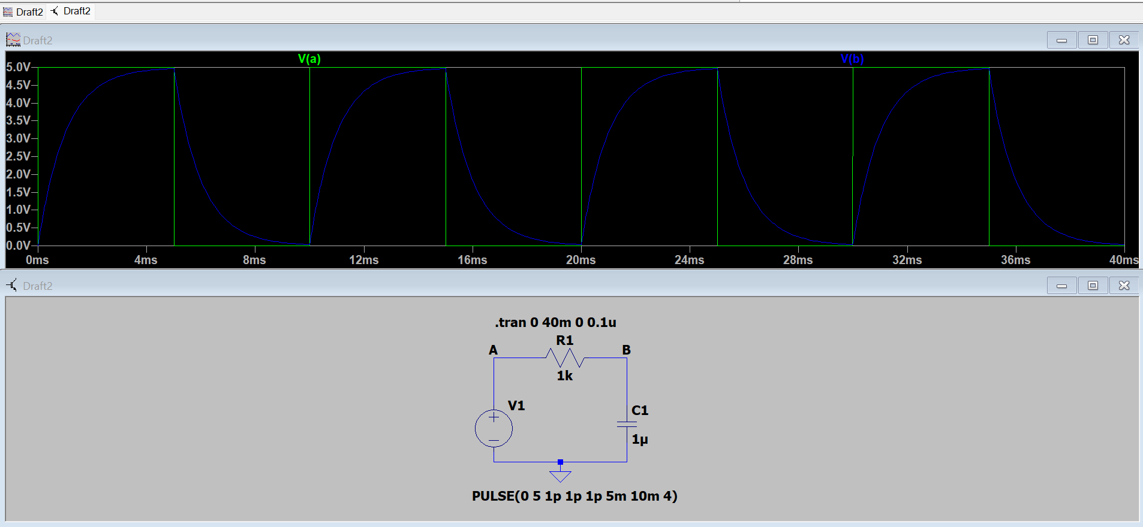

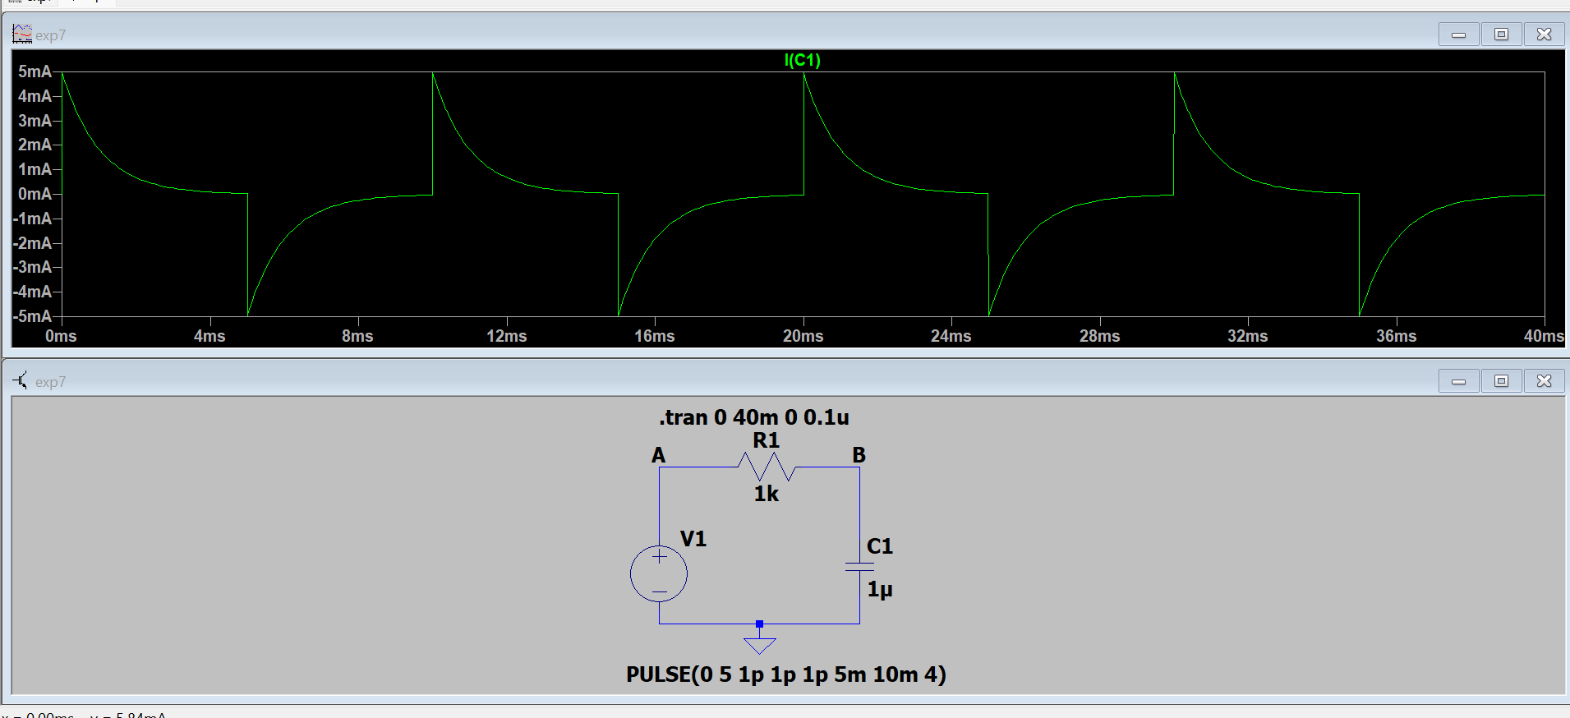

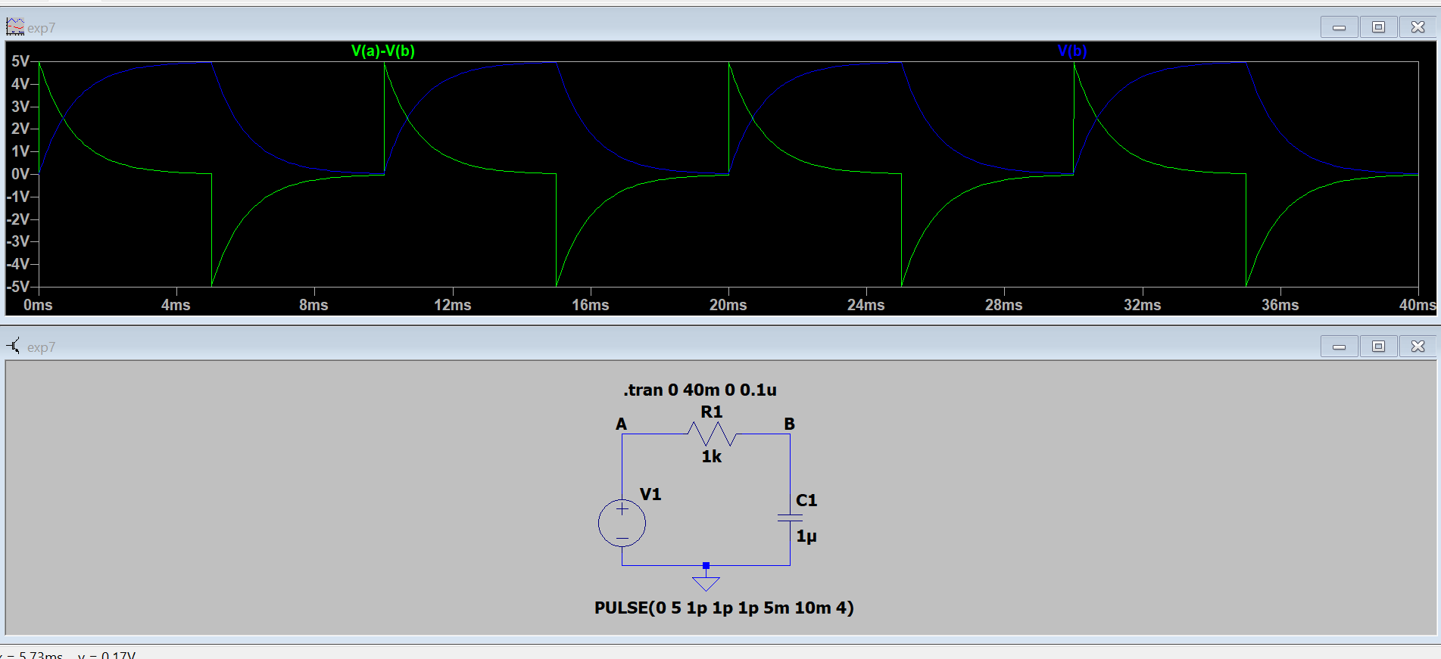

**Question**

**1. Define capacitor and capacitance. Write the features of a capacitor. What does capacitance measure?**

A capacitor is a passive component with two conducting plates separated by an insulator that is used to store energy in its electric field (or dielectric). Capacitance, which is measured in farads, is the proportion of a capacitor's charge to its voltage differential between its two plates (F). A capacitor has two conducting plates that are spaced apart by an insulator or dielectric. By measuring the amount of separated electric charge kept in the capacitor for every unit change in electrical potential, capacitance can be calculated.

2**. Deduce the voltage-current relationship for a capacitor. Why the voltage across a capacitor cannot change instantaneously?**

Mathematically, I = C(dv/dt), where C is the capacitor's capacitance value in farads and dv/dt is the rate of change of the supply voltage with respect to time, can be used to express the relationship between this charging current and the rate at which the capacitor's supply voltage varies. The derivative is not finite if the voltage abruptly shifts from one value to another (i.e., discontinuously). This suggests that an infinite current would be needed to adjust the voltage quickly. This means that the voltage cannot change instantly since an infinite current is not physically possible.

**3. Draw and explain the current waveform observed during both the charging and discharging phases.**

Charging phase:

The curves show that the charging current is greatest in the beginning, or when C is discharged. When the capacitor voltage changes to V, it starts to decline exponentially and eventually stops at zero.

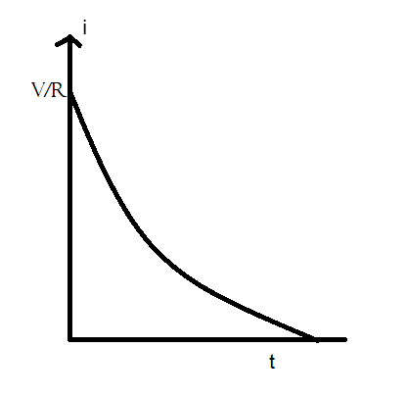

Discharging phase:

When the capacitor voltage drops to zero, the charging current stops and eventually reaches its maximum value at the beginning.

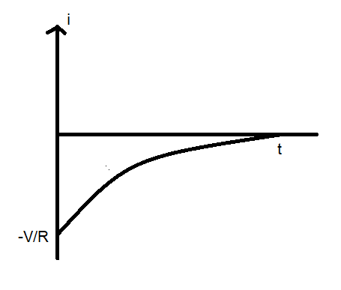

**4. Define time constant for an RC circuit. What is the significance of time constant? How time constant can be determined?**

A circuit's time constant describes the transient responsiveness of the circuit's currents and voltages as they change over a predetermined time period. The rate at which a state transitions from one stable condition to another is typically governed by the circuit's time constant. Circuit capacitance and circuit resistance can be multiplied to find the time constant (farads).

**5. Describe the charging and discharging phase of an RC circuit both qualitatively and quantitatively.**

A capacitor is in the charging phase when a charge accumulates on its plates, and it is in the discharging phase when a charge is discharged from those plates.

The voltage between the capacitor plates is zero and both of the capacitor's plates are capable of either absorbing or providing charge at time t=0. By shutting the switch at time t=0, a plate is connected to the positive terminal and another to the negative terminal. The charging current during the charging phase is represented by this electron movement. The voltage across the capacitor increases as the charge is stored. There is essentially no current flowing when the source voltage and capacitor voltage have reached equilibrium.

The equations for charing are:

V= Ri + $(1/C)$ idt

i= (V/R)

R = V ${e^{-t/τ}}^{}$

Vc = V- VR

The switch is set up during discharging such that the resistive load, not the voltage source, is connected to the capacitor. The capacitor will now begin to lose its stored charge, and the voltage across it will begin to rise, acting as a source for the resistor. As the charge is drained, the capacitor voltage will begin to decrease. For a constant resistance, the current will also start to fall as the voltage falls. The voltage across the capacitor will eventually drop to zero at a 5-time constant.

The equations for discharging are:

0= Ri + $(1/C)$ idt

i= (V/R)

R = V ${e^{-t/τ}}^{}$

Vc=V $e^{-t/τ}$